The r21 Simfile Making Guide v. 1.0
By Insane Steve

Intermediate Guide:

This part of my simfile making guide includes the following topics:

Part 1: Making Your Files More Fun
I: Selecting appropriate music
II: Crossovers and how to use them
III: The concept of “facing left vs. facing right”
IV: Stops and BPM changes
V: “Molding” steps to the song (the simple version)

Part 2: ITG Note Concepts
I: Mines
II: Hands
III: Freeze Rolls (basic)

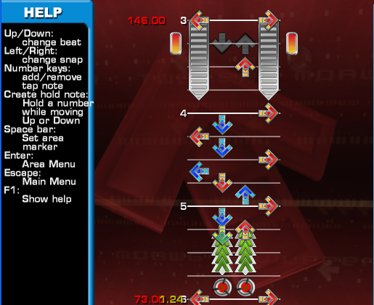

Introduction:

Ok, from the first part of this guide, you should have some idea how to make a file r21 compatible, and some idea how to make a file playable on pad. You may be able to make a playable, fun file with just the advice I gave you in the first part of this guide. However, many players get bored if you make your files with nothing but straightforward patterns and the same rhythms over and over again. This part of the guide will show you things you can put in your simfiles to make them universally more fun to play. It’s quite a bit longer than the last part, but it has quite a bit more information.

Part 1.1: Selecting a Music

The great thing about r21 is that it allows the player to play pretty much any song they want with a simfile on an arcade cabinet (within reason. Please don’t abuse the .ogg patch and play the 2 hour long DDR Megamix when there’s a line of people waiting to play). Some songs, however, are much easier to step, and will yield much more interesting files when you step them. For example, a song that switches up its rhythms frequently or has very interesting note patterns will be easier to make a fun simfile to than some generic trance song that repeats the same 8 measure pattern over and over and over again. For a good example of what not to try to step, find a simfile for the song “Inori” from IIDX.

A very good guideline that I like to use is that if I can’t hear the exact pattern of a song I want to step, or if that pattern repeats itself for over half the song, I won’t step it. There’s something to be said for cutting your music, also. It’s bad to step a 2 minute generic trance song, it’s much worse to step a 7 and a half minute extended mix of this trance song. (By the way, I have nothing against trance, it just, for the most part, yields dull, repetitive simfiles.) That’s about it, really. Just make sure you have ideas for the song; don’t step a song just because you like it. Oh, and to re-iterate a point I made in the first part of the guide, don’t force a difficulty onto a song. Make a chart that fits the song.

Part 1.2: Using crossovers to accent a song

Ok, now that I wasted a page telling you what song to step, we can actually begin making the simfile. I explained how to make basic stream earlier in the first part of the guide. I did, however, tell you to avoid “crossover” steps. Here, I will show you how to add basic crossovers into your streams, and also where to add these crossovers.

Simply put, a crossover is any step pattern where, if the player chooses to alternate feet between every step, causes the player to step on the left panel with his right foot, or the right panel with his left foot. An example of this pattern is LDRDUR. See the picture for how you can cross this pattern over.

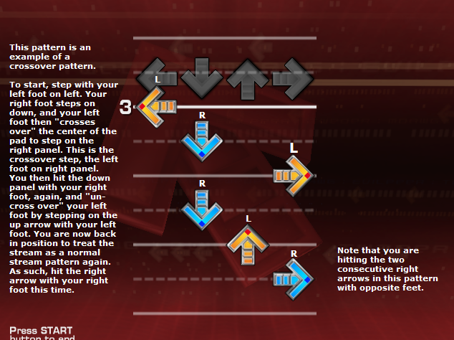

More common crossover patterns include LDRDL, or its mirror, RDLDR. In each, the third step is a crossover step, and the player is uncrossed over by the fifth step.

Recognizing crossover patterns is the first step to using them effectively in simfiles. When you play a file with crossovers, do you actually cross them over, or are you double stepping? Try to at least learn how to crossover, even if you can’t yet pass songs with 8th note crossover stream. Not only will it help you make files, it will also help you when you do move up to charts with faster streams with crossovers.

Ok, so you knew what crossovers were before you read this, and instead want to know exactly where to place them. There are really no set rules to placing crossovers in your streams, honestly. One guideline I like to use is that a crossover is more “prominent” of a step pattern than a normal stream pattern, so I like to use them to “highlight” parts of music, although that in itself could mean almost anything. Here are some ideas to start:

- To highlight a more intense section of a song. For example, let’s say you have a part of a song which you stepped with a four measure long basic (crossoverless without double stepping) 8th note stream. If the music repeats itself, but with more things going on in the music, you may wish to place some crossovers in the stream if you want to step the same eighth note pattern. Or, if the same part of a song loops later in the song, put some crossovers in the stream to mix your file up a bit.

- To accent an outstanding note or sound in a song. If you’re stepping a part of a song and it seems to “stick out” somewhat, put a crossover to accent this note or sound.

- As the major challenge of a file. Look at a chart like Soapy Bubble or Bloodrush Expert. The crossovers really don’t accent anything because they’re everywhere in the chart. If you think a song warrants itself to a crossover-filled chart, make a crossover-filled chart. Of course, make sure each crossover can be done without awkward stepping – there’s a couple parts in even official charts (the end of Soapy Bubble has a couple crossovers that can’t even be done correctly) that have this problem. Also remember that crossover steps are harder than regular stream, so rate your file accordingly.

- Really, anywhere else that a crossover seems to work. This is where practice helps out in making simfiles. While you can’t just put crossovers anywhere, if it seems to work, it probably does.

Overall, though, it’s really up to you to decide where crossovers fit in a file.

Part 1.3: Facing “left” and “right”

Another complaint you see with a lot of playable but improvable simfiles is that “you’re facing the same direction for too long”. What is meant by this is that certain patterns of arrows will cause the player’s body to be tilted towards the left corner of the pad, and others will cause the player to face the right corner of the pad. There are still others that cause the player to face straight forward, and patterns that allow the player to switch from these positions.

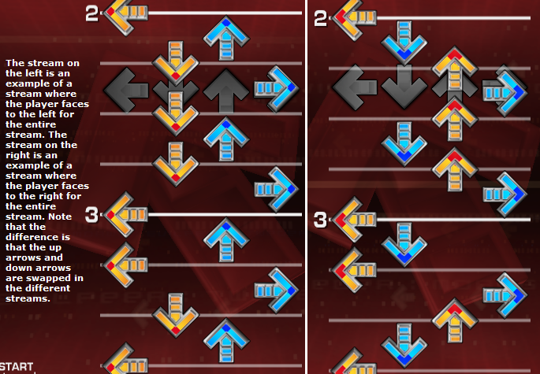
Left Right

How can you tell if a section of your streams face left or face right? Try to imagine yourself actually standing on the pad, playing your file. If, say, your left foot is on the left panel, you are facing toward the left if your right foot s on the up panel, you are facing to the right if your right foot is on the down panel, and are facing forward if your right foot is on the right panel.

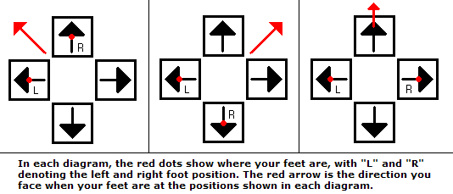

Here’s a list of the positions that cause you to face each direction:

Facing left: Left foot L, Right foot U
Left foot D, Right foot R or U.

Facing right: Left foot L, Right foot D
Left foot U, Right foot R or D.

Can be either/facing forward: Left foot L, Right foot R.

Note that the left L right R combination is just something that keeps you facing in the same direction as you were facing for most stream sections. If you look at your simfile and see that your feet positions result in you facing the same direction for a long time, you may want to change your step patterns. As an aside, you see a lot more files where you face right too long than files where you face left too long, mainly because right-facing patterns look like neat staircases in the Stepmania editor and are a lot easier to put down subconsciously than left-facing patterns.

How do you change direction? There’s a few “transition” note patterns to change the direction you face; if you are facing left, a pattern like DRU or DRLD (start with left foot) or ULRU or ULD (start with right foot) will allow you to face right. If you are facing right, a pattern like DLU or DLRD (start with right foot) or URD or URLU (start with left foot) allows you to face to the right. In general, the “three note” shifts are harder to pad than the “four note” shifts because one foot has to travel across the entire pad (that is, it goes farther) for the three note shift patterns. So… if you have very fast 16th stream and you want to shift direction, use the four note patterns, not the three note patterns.

Alternatively, a pattern like DRLRU or URLRLRD (start both with left foot) also changes the direction you face without forcing a foot all the way across the pad at once.

This is one of those things that, the more you make simfiles, the easier you’ll be able to “see” which way you face in a stream and can adjust. I know, I say this about everything you think about in making a simfile. It really is true, though.

Part 1.4: Stops and BPM Changes

Another thing you can do to make your file interesting is to add a stop or change the BPM of the song. This is yet another (much more obvious) way to accent certain features of the music you are stepping.

Stops can be as simple as one place in the chart where everything in the song just completely stops, to multiple stops during short tics in the music. There’s plenty of reasons to place a stop in a chart, but a couple of guidelines you should follow when placing stops in a chart.

- First, you should figure out exactly how long you want your stop to be, in beats. When placing a stop into a chart, you generally want to make sure the player has enough time to react to when the chart starts again. I generally will place a beat of time between the end of the stop and the first step unless I want the challenge of the chart to partly be in tricky stops and BPM quirks, in which case I may justify only having a half a beat of adjustment time. As a general rule, though, try to give the player a full beat or more of reaction time in a typical, non-tricky chart.
- Next, you need to figure out how long, in seconds, this stop is. You do this by finding the length of one beat, and multiplying that by the number of beats of your stop. To find the length of one, beat, set the note placement tool to place 4th (red) notes, and mark down the time (look in the top right corner of the screen) of two consecutive quarter note beats. Subtract the two and you have the length of one beat. For example, let’s say you find two beats in a row to be on seconds 32.616 and 32.980. The length of one beat is 0.364 seconds, and the length of a 3 beat stop is 1.092 seconds. … Wait, you can’t use F9 or F10 to get exactly that? There’s an option in the escape menu, “Edit Stop”, where you can type in the exact length of your stop. Unlike setting a BPM, only being able to add or subtract in .02 increments will likely mess up your file’s sync.

- About sync… stops should NEVER be used as a substitute for incorrect BPM or GAP. It’s just… annoying. If you find your file gets off-sync, re-check the BPM – the song might not have a constant BPM. Again, sync is the one thing I’m not good at, so you’ll need to find a sync guide for syncing variable BPM files.

BPM changes are one of those things which can make a file memorable… but can also ruin a file if you use them poorly. Assuming the actual BPM of the song remains constant, there are two major types of BPM changes: the slowdown (1/2 x BPM) and the speedup (2x BPM).

Slowdowns work best when a major part of the song just sort of suddenly drops out. It works well for the fancy lyrical breaks of electronica, or any part where there’s suddenly no percussion at all, or… you get the idea. That said, slowdowns in parts where there’s no really big major change to the tone of the song are generally awkward. Also make sure that you end the slowdown in a spot that makes sense (that is, whenever the musical stylistic thing that you put in the slowdown for stops). One other thing about slowdowns: generally, if the true BPM of a song does not change, you should not try to get fancy and slow the BPM to 3/4th the tempo and sync everything to orange notes. Except under VERY rare circumstances, keep your slowdowns to 1/2 BPM slowdowns.

My advice for BPM doubling is incredibly succinct and easy to follow. Don’t. I don’t care how intense or Max-sounding your song suddenly becomes, there’s really no reason to give a 155 BPM song a 310 BPM section. It’s obnoxious for the player (forcing the player to pick a much slower than normal speed mod) and often the song doesn’t have enough going on to justify a BPM doubling. Konami’s been doing this very often recently – look at Healing D-Vision, Trim, or that Insaner L.E.D. remix from Ultramix 4. Do any of those make sense?

There’s one other BPM change to discuss: the variable slowdown/speedup, where you slowly lower or increase the BPM to fit some sort of distortion in the song. You can have a slowdown to a sort of distorting of a song to sound slower, or a speedup to a “revving” up of the music. If you plan to use one of these, make sure your file stays on sync after you’re done (if you can’t get the file back on sync, just don’t use the BPM change). Also, I’d recommend not placing any notes until the BPM is back to normal – your notes in the slowdown would be offbeat and probably very hard to sync, and notes in the speedups would just be too fast to hit.

Part 1.5: Molding note patterns to the music

Another very good way to make your note charts fun is to design the arrow patterns to go with the song you are stepping. I think the best way to describe what I mean is by example. Let’s say you have a slower 16th note section with two alternating notes. It makes sense, then, to step to this alternating note section on two arrows, alternating back and forth between the two (a drill). Let’s say you have a song pattern that goes back and forth between one pitch and a series of increasing pitches, in a sort of 121314151 pattern. You can step all the identical notes on the same arrow, and switch up the other notes. For example, this can be stepped as LULRLDLRL. If you have a section of 5 8th notes in a row on the same pitch, maybe try stepping all of them on the same arrow (a jackhammer). If you have a descending scale of notes in the song, you can step them as RUDLRUDL… to make a neat looking descending staircase with the arrows on the screen. The possibilities for this are endless, and [insert yet another comment about your steps getting better the more you practice step making here].

Part 2: ITG exclusive chart concepts

So, if you’ve actually read to this point and paid attention to what I’ve said, you have the knowledge to make a good, solid, fun DDR style simfile. But, ITG has support for so many different types of charts that DDR does not. Three of the better known ITG exclusive chart concepts are mines, hands, and freeze rolls. Incorporating these into you r21 ready charts will give your charts the same feel as an ITG official chart if you use them well.

Part 2.1: Using mines

Mines are a part of ITG that, from my experience, yields mixed opinions from a lot of the players I’ve known. Some people find mines very fun to try to avoid and neat to look at, other people absolutely cannot stand mines and I’ve seen some turn off mines in charts. Most people are in between these extremes, so you should at least learn some places in charts where mines fit very well.

For starters, there are a few things you should know before using mines. For one, don’t place mines way too close to the arrows. If you do, it will be too easy to hit the mine (and subsequently, miss the note). I’ve seen files with mines that were literally impossible to miss if you try to hit the arrow. Try to keep between 3/8ths and 1/2 of a beat between the mine and the arrow depending on the BPM of the song. Also, don’t put way too many mines in a small space. It can lag the game, and that many mines generally aren’t even needed.

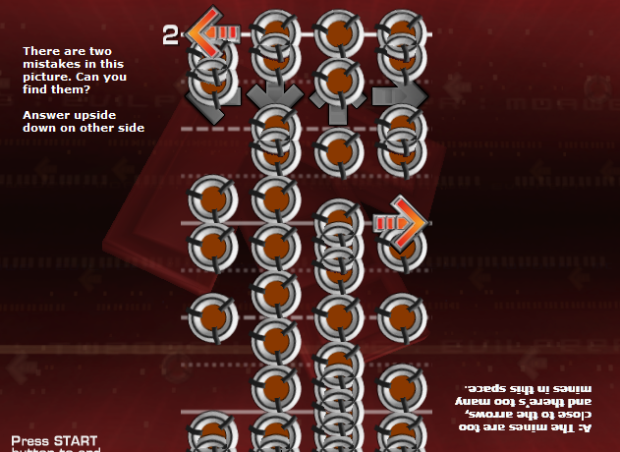

Now, where are good places to place mines? Here are a few ideas.

- Directly after a note to force the player to remove his foot quickly after stepping on the arrow. These fit best when a sound cuts off more quickly than most sounds in a song, since you’ll have to “pop” your foot off the pad before the mine hits. A variation of this is placing a mine after the end of a freeze to force the player to keep his foot down for a specific length of time; too long and you’ll hit the mine, too short and the freeze drops.

- In lines or after notes to force the player to jump off the notes or back to the center of the pad. If there’s a “line” of mines (that is, mines on all four arrows at the same time), the player will more than likely instinctively jump to the center of the pad instead of merely jumping over the mines.

- As decoration, or to look really cool. There’s plenty of examples of charts with mines to “fill” empty space when the song becomes harsher in tone or more full. If there’s a complete lull in the song, a minefield can help to fill the void created by the music. If you have an especially hard hit that you have a jump on, place mines in the free arrows. You can also spell messages with mines if you want. You can completely fill your chart with mines in a way similar to VerTex or the like to change the overall feel of a chart. There’s several ways to decorate your chart with mines.

- You can use mines to make a player step in an unorthodox way, or show the player when he has to step in an unorthodox way. For example, in Hardcore of the North Hard, there's a section of 7 notes repeating near the beginning, and a row of 3 mines. At this row of mines, the player is supposed to "jump" the mines and switch feet even though two successive notes are on the same arrow. Other mines can be used to make the player step on multiple notes in a row with the same foot when alternating feet is more standard.

There’s all kinds of ways to incorporate mines into your chart. It’d take another 12 pages just to list them, so I’ll stop here and let you experiment.

Part 2.2: Hands

Hands are a concept that I see a lot of people mess up. They make hands that are too fast to hit, or too weird to try and bend over to hit, or hands that just flat out don’t work with the chart. I think the best way to begin to describe how to use hands is to describe how not to use hands.

- Don’t force the player to drop down and hit hands too quickly. A left-down freeze with an eighth note hand is almost always too fast to try to hit. Give the player enough time to drop down and set up for an upcoming hand, and also give the player enough time the get back up from your hands to continue playing the chart.

- Don’t use hand patterns that are obscenely awkward to try to hit. I seriously see far too many files that have hand patterns like left-up freeze, down-right hand, followed by placing the right foot onto right and hitting an up-down hand. Don’t do this ever ever ever. Here’s an easier to conceptualize example – you have a left-right freeze, facing forward. Which arrow is going to be easier to hit with your hands; the up arrow, which you’re facing right now, or the down arrow, which you’d sort of have to bend backwards to hit? Up is easier to hit.

- Don’t place hands so close to the ends of freezes that you can hit them with your feet just as easily without dropping the holds. I see a lot of intended hands that are placed on the same beat a freeze ends, and it’s just so much easier to hit it with your foot and not worry about going down to hit it with your hands. Try to leave at least a half a beat of freeze after you have a hand to make the player hit the note with his hand (or actually return to the freeze if he wants to cheat the hand).

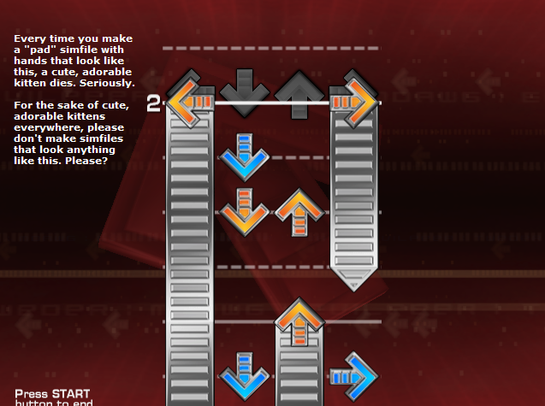

So now you have an idea of what not to do with hands. Here’s a few other pointers for hands.

- As I said, it’s better to try to keep the hands as not awkward as possible. There are also certain patterns of freezes that lend themselves better to not awkward hands. For example, it is much easier to drop down for hands if you are holding a down-right freeze than it is if you are holding an up-right freeze, since you have to bend back a bit to hit the hands in the latter, but you’re facing the panels you can hit for hands in the former. I’m not saying to never use the up-right freeze for hands, I’m just saying it takes more time to set up for these hands and more effort to re-orient yourself afterwards.

- Also, make sure that you have a lot of time for more complex hands. A pattern I see a lot that of people use where the player almost never has enough time to set up for is the LR-freeze UD-hands or the UD-freeze LR-hands (See Monolith Expert). These can be fun if you use them right, but you will need a lot of time to drop down to hit them, and then to get back up for the rest of the chart. If you feel like using these patterns but think you may not have enough time to get ready for them, simplify the hand pattern to only needing to hit one arrow with your hands, not both.

- Triples and quads are also somewhat hard to use properly. What you need for them is a lot of time to get ready for them (or, you need to be in a position where dropping for a triple or quad is not at all awkward), and a very pronounced hit or sound effect to step a triple or quad to that a jump wouldn’t be better to use. If you’re just starting placing hands in a file, I recommend you stay away from triples and quads for now.

- More isn’t always better for hands, either. I’ve seen a lot people try to make Queen of Light II but instead turn out something unplayable and awkward (I myself could be included in this camp, looking at some of my earlier edits). If you want to make hands the central theme of a chart, awesome, just make sure they aren’t awkward and bad. Which, to be honest, is a much harder task than you’d think.

Part 2.3: Freeze rolls

The last (and often overlooked) ITG exclusive simfile tool is the freeze roll, a note you have to hit repeatedly. A lot of file makes don’t even know how to place a roll in a file. There’s two ways to do it:

The easy way: Get a simfile editor that supports rolls, like Stepmania 3.95 CVS, 4.0, or mDaWg’s ITGPC. Hold shift, and place your roll like you would any other typical freeze.

The hard way: If you don’t have such a build of Stepmania and don’t want to download one, replace the rolls with regular freezes in your original simfile. After exiting Stepmania, open the .sm file in a text editor and scroll to the measures where you want your freeze rolls. Find the “2”s in the columns of numbers (these denote the beginning of a standard freeze) and replace them with “4”s (these denote the beginning of rolls).

The most common place to put rolls in a file is when there’s a very fast alternate trill of notes that you don’t feel like or can’t step individual notes to. There’s really not a whole lot to say about when rolls work, because it’s generally obvious. There are a couple other things I should comment on about rolls:

Like freezes in general, if your rolls are so short that you only have to hit the initial note to complete the roll, you need to either lengthen the roll or remove it. There may be stylistic reasons to have such short rolls, but most of the time your rolls should require two or more taps to complete.

Also, for a pair of rolls, you should usually offset one of the two rolls by whatever amount of time the distance between the first two trills of the sound the rolls go to (This is usually a 16th note apart). You’re going to be alternating steps with the rolls, and it’s a lot harder to get this going if you have to get both rolls to start at the same time than if you start by alternating feet.

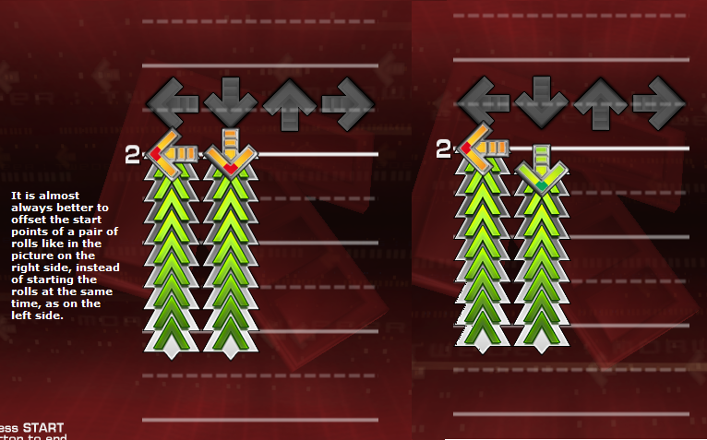

Wrap Up:

There’s a very good reason that the 2nd part of this guide was so long. The transition from just starting to make pad playable files to consistently making fun files is one that takes a lot of time and practice. The information written in this part of the guide may take a lot of work to understand, but once you do, your files will become so much better.

In the 3rd and final installment of my guide, I’ll give some examples of rarer, more interesting and unique things you can do with your simfiles that will make them outstanding.

